Results early trial - overall SR

Jesse Wood

April 15, 2018

## R Markdown

This is an R Markdown document. Markdown is a simple formatting syntax for authoring HTML, PDF, and MS Word documents. For more details on using R Markdown see <http://rmarkdown.rstudio.com>.

Setup

library("unmarked")

## Loading required package: reshape

## Loading required package: lattice

## Loading required package: parallel

## Loading required package: Rcpp

library("ggplot2")  
setwd("C:/Users/woodj/Documents/GRAD SCHOOL - CLEMSON/Project-Specific/R work/USDA-songbirds/USDA-songbirds")

# Point Count Data Only

## all 4 PC visits pooled ##

#sr_covs CSV file is SR by sites by point counts (pooled 1-4) file (NP flyovers excluded)  
richness <-read.csv("sr_covs.csv") #SR by sites by point count overall SR #all effort  
summary(richness)

## Site SR SRwoUNKNS YearCat Treatment  
## Battlewood_1B_8 : 1 Min. :19.00 Min. :19.00 A:51 0B:12   
## Battlewood_1B_E_B: 1 1st Qu.:22.50 1st Qu.:22.00 1B:13   
## Blease_3B_6 : 1 Median :25.00 Median :24.00 2B:12   
## Blease_3B_9 : 1 Mean :25.33 Mean :24.88 3B:14   
## Bryson_1B_9 : 1 3rd Qu.:27.00 3rd Qu.:26.50   
## Bryson_2B_9 : 1 Max. :41.00 Max. :40.00   
## (Other) :45   
## Nthins Nburns BA Herbicide   
## Min. :0.000 Min. : 0.000 Min. : 38.00 Min. :0.0000   
## 1st Qu.:1.000 1st Qu.: 1.000 1st Qu.: 74.50 1st Qu.:0.0000   
## Median :2.000 Median : 2.000 Median : 90.00 Median :1.0000   
## Mean :1.784 Mean : 2.078 Mean : 85.31 Mean :0.5882   
## 3rd Qu.:2.000 3rd Qu.: 3.000 3rd Qu.: 97.00 3rd Qu.:1.0000   
## Max. :6.000 Max. :12.000 Max. :124.00 Max. :1.0000   
##   
## Age Parea TimeSinceB TimeSinceT   
## Min. :15.00 Min. : 15.84 Min. : 0.00 Min. : 0.00   
## 1st Qu.:21.00 1st Qu.: 29.45 1st Qu.: 1.00 1st Qu.: 1.50   
## Median :26.00 Median : 46.92 Median : 2.00 Median : 3.00   
## Mean :26.98 Mean : 78.01 Mean :13.51 Mean : 5.02   
## 3rd Qu.:31.00 3rd Qu.: 97.75 3rd Qu.:10.00 3rd Qu.: 6.00   
## Max. :57.00 Max. :267.63 Max. :50.00 Max. :50.00   
##   
## Nsnags Ccover Ldepth TreeHt   
## Min. :0.0000 Min. :55.59 Min. :0.150 Min. :46.43   
## 1st Qu.:0.0000 1st Qu.:86.66 1st Qu.:1.250 1st Qu.:59.23   
## Median :0.4000 Median :91.63 Median :1.738 Median :67.88   
## Mean :0.8275 Mean :89.58 Mean :1.930 Mean :66.96   
## 3rd Qu.:1.3000 3rd Qu.:95.68 3rd Qu.:2.663 3rd Qu.:74.95   
## Max. :4.4000 Max. :99.22 Max. :4.263 Max. :81.67   
##   
## HWdens_10 HWdens_50 HWdens_100 FG_herb   
## Min. : 3.00 Min. : 0.60 Min. : 1.20 Min. :0.0140   
## 1st Qu.:12.00 1st Qu.: 9.40 1st Qu.: 5.80 1st Qu.:0.1695   
## Median :23.80 Median :15.60 Median :10.40 Median :0.4080   
## Mean :23.93 Mean :20.05 Mean :14.14 Mean :0.3981   
## 3rd Qu.:33.40 3rd Qu.:27.50 3rd Qu.:18.35 3rd Qu.:0.6355   
## Max. :65.80 Max. :66.20 Max. :52.60 Max. :0.9220   
##   
## FG_shrub NHW_saplings NP_over_20cm Rel_HW2P_canopy   
## Min. :0.00000 Min. : 0.000 Min. :1.4 Min. :0.0000   
## 1st Qu.:0.00000 1st Qu.: 1.600 1st Qu.:2.8 1st Qu.:0.0600   
## Median :0.01500 Median : 4.200 Median :4.0 Median :0.1500   
## Mean :0.06708 Mean : 7.471 Mean :3.8 Mean :0.1788   
## 3rd Qu.:0.11000 3rd Qu.:10.000 3rd Qu.:4.6 3rd Qu.:0.2450   
## Max. :0.34200 Max. :41.000 Max. :7.2 Max. :0.5500   
##   
## Rel_HW2P_shrubcover LCR HW_dens_1050 HW_shrub   
## Min. :0.4000 Min. :0.3500 Min. : 5.80 Min. : 0.60   
## 1st Qu.:0.7819 1st Qu.:0.4500 1st Qu.: 22.43 1st Qu.: 5.10   
## Median :0.9842 Median :0.4700 Median : 39.40 Median :11.30   
## Mean :0.8634 Mean :0.4833 Mean : 43.94 Mean :14.53   
## 3rd Qu.:1.0000 3rd Qu.:0.5150 3rd Qu.: 60.90 3rd Qu.:20.75   
## Max. :1.0000 Max. :0.6400 Max. :106.00 Max. :50.50   
##   
## ShapeIndex PAratio FracDimIndex CoreAreaIndex   
## Min. :1.000 Min. :0.005524 Min. :1.018 Min. :0.0000   
## 1st Qu.:1.222 1st Qu.:0.009608 1st Qu.:1.037 1st Qu.:0.0000   
## Median :1.333 Median :0.012222 Median :1.050 Median :0.1034   
## Mean :1.359 Mean :0.012871 Mean :1.055 Mean :0.1458   
## 3rd Qu.:1.500 3rd Qu.:0.014773 3rd Qu.:1.065 3rd Qu.:0.1968   
## Max. :1.750 Max. :0.028571 Max. :1.114 Max. :0.5048   
##   
## Ag500m Ag1km Ag5km Ag30km   
## Min. : 0.0000 Min. : 0.000 Min. : 135.2 Min. : 25072   
## 1st Qu.: 0.0000 1st Qu.: 6.233 1st Qu.:1001.1 1st Qu.: 47632   
## Median : 0.2289 Median : 34.862 Median :1787.5 Median : 72287   
## Mean : 8.8954 Mean : 49.312 Mean :2521.7 Mean : 69494   
## 3rd Qu.:16.4880 3rd Qu.: 75.096 3rd Qu.:3510.9 3rd Qu.: 90541   
## Max. :50.4053 Max. :202.823 Max. :7570.0 Max. :111459   
##   
## Evergreen500m Evergreen1km Evergreen5km Evergreen30km   
## Min. : 3.503 Min. : 35.02 Min. :1022 Min. : 34874   
## 1st Qu.: 56.341 1st Qu.:170.83 1st Qu.:2682 1st Qu.: 79692   
## Median : 68.303 Median :225.00 Median :4310 Median :105441   
## Mean : 67.566 Mean :219.37 Mean :4339 Mean :108143   
## 3rd Qu.: 79.665 3rd Qu.:273.04 3rd Qu.:5911 3rd Qu.:135174   
## Max. :121.784 Max. :480.32 Max. :9153 Max. :191963   
##   
## Imperv500m Imperv1km Imperv5km Imperv30km   
## Min. :0.00000 Min. : 0.0000 Min. : 0.000 Min. : 916.4   
## 1st Qu.:0.00000 1st Qu.: 0.0000 1st Qu.: 3.641 1st Qu.: 2961.6   
## Median :0.00000 Median : 0.0000 Median : 9.382 Median : 4965.7   
## Mean :0.01461 Mean : 0.5003 Mean : 37.597 Mean : 5696.4   
## 3rd Qu.:0.00000 3rd Qu.: 0.0000 3rd Qu.: 33.566 3rd Qu.: 5677.8   
## Max. :0.44479 Max. :13.5661 Max. :286.299 Max. :28615.3   
##   
## Protected30km HighDev500m HighDev1km HighDev5km   
## Min. : 2696 Min. :0.000000 Min. : 0.0000 Min. : 0.000   
## 1st Qu.: 3940 1st Qu.:0.000000 1st Qu.: 0.0000 1st Qu.: 1.331   
## Median : 22450 Median :0.000000 Median : 0.0000 Median : 4.307   
## Mean : 47994 Mean :0.002986 Mean : 0.3607 Mean : 22.744   
## 3rd Qu.: 65906 3rd Qu.:0.000000 3rd Qu.: 0.0000 3rd Qu.: 19.610   
## Max. :176398 Max. :0.152272 Max. :11.1948 Max. :182.736   
##   
## HighDev30km LowDev500m LowDev1km LowDev5km   
## Min. : 769.2 Min. :0.0000 Min. : 0.0000 Min. : 6.53   
## 1st Qu.: 3502.8 1st Qu.:0.0000 1st Qu.: 0.0000 1st Qu.: 34.70   
## Median : 5431.2 Median :0.0000 Median : 0.4443 Median : 62.91   
## Mean : 6566.1 Mean :0.4534 Mean : 1.8887 Mean :105.40   
## 3rd Qu.:11283.4 3rd Qu.:0.4096 3rd Qu.: 2.4143 3rd Qu.:146.99   
## Max. :13882.0 Max. :7.2161 Max. :11.3891 Max. :659.65   
##   
## LowDev30km OpenDev500m OpenDev1km OpenDev5km   
## Min. : 2613 Min. : 0.0000 Min. : 0.00 Min. : 218.9   
## 1st Qu.: 6766 1st Qu.: 0.5517 1st Qu.: 7.45 1st Qu.: 407.9   
## Median : 8115 Median : 4.2493 Median :14.75 Median : 547.3   
## Mean : 9311 Mean : 4.4336 Mean :17.21 Mean : 600.9   
## 3rd Qu.: 9672 3rd Qu.: 6.0598 3rd Qu.:24.76 3rd Qu.: 718.0   
## Max. :33558 Max. :19.0889 Max. :48.28 Max. :1502.5   
##   
## OpenDev30km Grass500m Grass1km Grass5km   
## Min. :11949 Min. : 0.000 Min. : 0.00 Min. : 281.6   
## 1st Qu.:17847 1st Qu.: 4.487 1st Qu.: 37.78 1st Qu.:1033.8   
## Median :28312 Median :13.219 Median : 53.57 Median :1134.2   
## Mean :26293 Mean :12.001 Mean : 58.08 Mean :1176.4   
## 3rd Qu.:30707 3rd Qu.:16.198 3rd Qu.: 70.83 3rd Qu.:1401.5   
## Max. :64514 Max. :33.466 Max. :141.11 Max. :2086.2   
##   
## Grass30km Schrubs500m Schrubs1km Schrubs5km   
## Min. :22579 Min. : 0.0000 Min. : 0.00 Min. : 107.7   
## 1st Qu.:35440 1st Qu.: 0.0000 1st Qu.: 4.62 1st Qu.: 301.2   
## Median :37699 Median : 0.8899 Median : 10.20 Median : 437.5   
## Mean :38273 Mean : 4.9557 Mean : 17.58 Mean : 507.7   
## 3rd Qu.:42510 3rd Qu.: 3.9229 3rd Qu.: 21.72 3rd Qu.: 731.2   
## Max. :58198 Max. :36.0898 Max. :102.76 Max. :1138.8   
##   
## Schrubs30km Water500m Water1km Water5km   
## Min. : 6023 Min. :0.0000 Min. : 0.000 Min. : 1.855   
## 1st Qu.:14007 1st Qu.:0.0000 1st Qu.: 0.000 1st Qu.: 38.364   
## Median :19221 Median :0.0000 Median : 0.000 Median : 65.257   
## Mean :18528 Mean :0.5581 Mean : 3.124 Mean : 389.777   
## 3rd Qu.:21292 3rd Qu.:0.0000 3rd Qu.: 4.552 3rd Qu.: 209.723   
## Max. :28026 Max. :6.6713 Max. :21.007 Max. :2797.286   
##   
## Water30km NSoilTypes FPSiteIndex SiteIndexPrimaryS  
## Min. : 2138 Min. :2.000 Min. :70.73 Min. :67.00   
## 1st Qu.: 4039 1st Qu.:3.000 1st Qu.:75.15 1st Qu.:73.00   
## Median : 7062 Median :4.000 Median :79.86 Median :80.00   
## Mean :11648 Mean :4.431 Mean :78.55 Mean :77.81   
## 3rd Qu.:12738 3rd Qu.:5.500 3rd Qu.:81.22 3rd Qu.:80.50   
## Max. :45376 Max. :8.000 Max. :84.81 Max. :85.00   
## NA's :4 NA's :4   
## PISoils SISoils HydricSoils   
## Min. : 0.0 Min. : 0.00 Min. :0.0000   
## 1st Qu.: 6.5 1st Qu.: 7.65 1st Qu.:0.0000   
## Median : 19.4 Median :30.70 Median :0.0000   
## Mean : 28.8 Mean :31.10 Mean :0.1124   
## 3rd Qu.: 49.8 3rd Qu.:47.05 3rd Qu.:0.0600   
## Max. :100.0 Max. :87.60 Max. :1.0130   
##

str(richness)

## 'data.frame': 51 obs. of 76 variables:  
## $ Site : Factor w/ 51 levels "Battlewood_1B_8",..: 1 2 3 4 5 6 7 8 9 10 ...  
## $ SR : int 21 24 32 27 23 23 27 21 25 22 ...  
## $ SRwoUNKNS : int 21 24 32 26 22 21 27 20 24 22 ...  
## $ YearCat : Factor w/ 1 level "A": 1 1 1 1 1 1 1 1 1 1 ...  
## $ Treatment : Factor w/ 4 levels "0B","1B","2B",..: 2 2 4 4 2 3 4 2 1 3 ...  
## $ Nthins : int 1 1 2 2 3 3 3 2 0 1 ...  
## $ Nburns : int 1 1 4 12 1 2 3 1 0 2 ...  
## $ BA : int 81 84 102 87 92 91 90 77 100 81 ...  
## $ Herbicide : int 0 0 1 1 1 1 1 1 0 1 ...  
## $ Age : int 32 20 32 37 35 35 35 29 27 42 ...  
## $ Parea : num 127 45.6 70 38.3 32.3 ...  
## $ TimeSinceB : int 1 1 0 0 7 3 0 2 50 2 ...  
## $ TimeSinceT : int 2 2 12 12 9 9 9 2 50 6 ...  
## $ Nsnags : num 1.6 0.2 0.4 2.6 0 0 0.2 0.4 2 4 ...  
## $ Ccover : num 88.4 88.2 98.1 88.3 92.7 ...  
## $ Ldepth : num 1.125 1.438 0.875 0.15 3.775 ...  
## $ TreeHt : num 76.7 61.9 81.3 70.1 73.8 ...  
## $ HWdens_10 : num 26.8 11.6 10.8 39.8 26.8 ...  
## $ HWdens_50 : num 35.4 7 12.5 66.2 28 24 11.8 6 20 2.8 ...  
## $ HWdens_100 : num 42.4 4.4 18.5 20.8 27 23.2 15.4 6 6.6 1.4 ...  
## $ FG_herb : num 0.244 0.182 0.296 0.868 0.042 ...  
## $ FG_shrub : num 0.035 0.195 0 0 0 0 0 0.05 0 0.125 ...  
## $ NHW_saplings : num 4.2 0.8 2 0 9.4 41 15.6 3.6 1.2 1 ...  
## $ NP_over_20cm : num 4 4.8 2.8 4 2.2 3.2 2.2 4 4 1.6 ...  
## $ Rel_HW2P_canopy : num 0.16 0.11 0.08 0.01 0.11 0.25 0.23 0.01 0.4 0.18 ...  
## $ Rel_HW2P_shrubcover: num 0.997 0.6 0.8 1 1 ...  
## $ LCR : num 0.45 0.57 0.45 0.53 0.47 0.38 0.49 0.46 0.57 0.45 ...  
## $ HW_dens_1050 : num 62.2 18.6 23.2 106 54.8 ...  
## $ HW_shrub : num 50.5 1.9 6 21.5 13.5 13.9 7.1 12.4 11.7 0.6 ...  
## $ ShapeIndex : num 1.67 1.22 1.36 1.11 1.11 ...  
## $ PAratio : num 0.00962 0.01222 0.01034 0.01176 0.01111 ...  
## $ FracDimIndex : num 1.08 1.04 1.05 1.03 1.03 ...  
## $ CoreAreaIndex : num 0.154 0.111 0.103 0.118 0.111 ...  
## $ Ag500m : num 0 0.00173 0.02255 2.01394 16.229 ...  
## $ Ag1km : num 15.7 24.8 49.2 54.7 86.4 ...  
## $ Ag5km : num 2520 3049 2637 2766 5031 ...  
## $ Ag30km : num 73534 73373 77585 77275 92150 ...  
## $ Evergreen500m : num 83.8 97.6 116.3 70.5 82.5 ...  
## $ Evergreen1km : num 219 304 275 262 247 ...  
## $ Evergreen5km : num 2836 2782 5449 5297 2502 ...  
## $ Evergreen30km : num 109886 109681 156445 155588 80777 ...  
## $ Imperv500m : num 0 0 0 0 0 0 0 0 0 0 ...  
## $ Imperv1km : num 0 0 0 0 0.453 ...  
## $ Imperv5km : num 24.31 25.11 3.89 7 20.19 ...  
## $ Imperv30km : num 4731 4940 1103 1102 5742 ...  
## $ Protected30km : num 58261 57938 12428 11966 22450 ...  
## $ HighDev500m : num 0 0 0 0 0 0 0 0 0 0 ...  
## $ HighDev1km : num 0 0 0 0 0 ...  
## $ HighDev5km : num 13.11 13.7 1.16 3.06 10.65 ...  
## $ HighDev30km : num 3208 3218 6030 6020 3495 ...  
## $ LowDev500m : num 0 0 0 0 3.49 ...  
## $ LowDev1km : num 0 0.22239 0.22239 0.00207 9.82324 ...  
## $ LowDev5km : num 108.9 109.4 38.5 41.8 144.2 ...  
## $ LowDev30km : num 9137 9339 2627 2635 10497 ...  
## $ OpenDev500m : num 0 1.14 4.72 1.87 8.97 ...  
## $ OpenDev1km : num 4.66 8.26 22.29 13.67 43.76 ...  
## $ OpenDev5km : num 754 727 599 629 599 ...  
## $ OpenDev30km : num 28174 28312 21727 21672 31045 ...  
## $ Grass500m : num 12.1 26.73 1.25 12.79 7.42 ...  
## $ Grass1km : num 47.7 53.6 36.3 26.9 60.8 ...  
## $ Grass5km : num 1125 1091 1485 1474 1030 ...  
## $ Grass30km : num 38080 38048 32369 32395 37699 ...  
## $ Schrubs500m : num 3.021 0.262 0 31.438 2.9 ...  
## $ Schrubs1km : num 14.53 10.17 37.67 42.93 5.78 ...  
## $ Schrubs5km : num 745 745 747 718 276 ...  
## $ Schrubs30km : num 14050 13850 20342 20413 14161 ...  
## $ Water500m : num 0 0 0 0 0 ...  
## $ Water1km : num 0 0 0 0 1.24 ...  
## $ Water5km : num 63.5 58.8 19.7 19.9 163.4 ...  
## $ Water30km : num 2138 2155 10573 10408 2886 ...  
## $ NSoilTypes : int 7 5 7 4 4 7 4 3 5 5 ...  
## $ FPSiteIndex : num 72.8 72.1 81.1 79.5 75.1 ...  
## $ SiteIndexPrimaryS : int 72 72 81 81 73 73 73 72 80 80 ...  
## $ PISoils : num 5.8 8.2 69.9 100 0 35.4 2.7 92.9 55.7 28.5 ...  
## $ SISoils : num 4.6 47.4 23.7 0 9.9 9.8 0 0 16 9.3 ...  
## $ HydricSoils : num 0 0 0.31 0 0 0 0 0 0 0 ...

#var(richness[2:5])  
#mean(richness[2:2])  
#mean(richness$SR)

lm(SR ~ Site, richness)

##   
## Call:  
## lm(formula = SR ~ Site, data = richness)  
##   
## Coefficients:  
## (Intercept) SiteBattlewood_1B_E_B   
## 2.100e+01 3.000e+00   
## SiteBlease_3B_6 SiteBlease_3B_9   
## 1.100e+01 6.000e+00   
## SiteBryson_1B_9 SiteBryson_2B_9   
## 2.000e+00 2.000e+00   
## SiteBryson_3B_E_B SiteBurnett_Pauline_1B_5   
## 6.000e+00 -1.432e-14   
## SiteCreswell_0B_8 SiteCreswell_2B_10   
## 4.000e+00 1.000e+00   
## SiteGosnell_0B_5A SiteGosnell_0B_5B   
## 6.000e+00 3.000e+00   
## SiteHood_Creek_0B_7 SiteHood_Creek_0B_HC   
## 2.000e+00 3.000e+00   
## SiteHoward_2B_4 SiteHudson_2B_7   
## -1.000e+00 1.200e+01   
## SiteHudson_2B_8 SiteKemp_0B_10   
## 5.000e+00 3.000e+00   
## SiteKemp_1B_1 SiteKemp_2B_2   
## 3.000e+00 4.000e+00   
## SiteKemp_2B_5 SiteKemp_3B_11   
## -2.000e+00 6.000e+00   
## SiteKessler_3B_4 SiteKessler_3B_5A   
## 1.000e+00 9.000e+00   
## SiteKessler_3B_5B SiteLivingston_3B_10   
## 1.100e+01 2.000e+01   
## SiteMathis_1B_6 SiteMathis_1B_7   
## 9.000e+00 9.000e+00   
## SiteMills_0B_9 SiteMills_1B_4   
## 6.000e+00 4.000e+00   
## SiteMills_1B_45 SiteShealy_0B_2   
## 5.000e+00 1.000e+00   
## SiteShealy_0B_4 SiteShealy_1B_3A   
## 8.000e+00 1.000e+00   
## SiteShealy_1B_3B SiteShealy_1B_E_S   
## 3.000e+00 -1.000e+00   
## SiteShealy_2B_3 SiteSuggs_0B_E_S   
## 5.000e+00 2.000e+00   
## SiteSwanson_2B_E_SW SiteSwanson_3B_2   
## 4.000e+00 8.000e+00   
## SiteTimberhaven_2B_1 SiteTimberhaven_3B_7   
## 4.000e+00 8.000e+00   
## SiteTimberhaven_3B_8 SiteTurkey_Rd_2B_6A   
## 2.000e+00 8.000e+00   
## SiteTurkey_Rd_2B_6B SiteTurner_Abercrombie_0B_E_AB   
## 6.000e+00 1.000e+00   
## SiteTurner_Abercrombie_1B_2 SiteTurner_Honea_Path_0B_1   
## -2.000e+00 -2.000e+00   
## SiteTurner_Honea_Path_0B_6 SiteTurner_Honea_Path_3B_1   
## 1.000e+00 6.000e+00   
## SiteTurner_Honea_Path_3B_3   
## 5.000e+00

summary(lm(SR ~ Site, richness))

##   
## Call:  
## lm(formula = SR ~ Site, data = richness)  
##   
## Residuals:  
## ALL 51 residuals are 0: no residual degrees of freedom!  
##   
## Coefficients:  
## Estimate Std. Error t value Pr(>|t|)  
## (Intercept) 2.100e+01 NA NA NA  
## SiteBattlewood_1B_E_B 3.000e+00 NA NA NA  
## SiteBlease_3B_6 1.100e+01 NA NA NA  
## SiteBlease_3B_9 6.000e+00 NA NA NA  
## SiteBryson_1B_9 2.000e+00 NA NA NA  
## SiteBryson_2B_9 2.000e+00 NA NA NA  
## SiteBryson_3B_E_B 6.000e+00 NA NA NA  
## SiteBurnett_Pauline_1B_5 -1.432e-14 NA NA NA  
## SiteCreswell_0B_8 4.000e+00 NA NA NA  
## SiteCreswell_2B_10 1.000e+00 NA NA NA  
## SiteGosnell_0B_5A 6.000e+00 NA NA NA  
## SiteGosnell_0B_5B 3.000e+00 NA NA NA  
## SiteHood_Creek_0B_7 2.000e+00 NA NA NA  
## SiteHood_Creek_0B_HC 3.000e+00 NA NA NA  
## SiteHoward_2B_4 -1.000e+00 NA NA NA  
## SiteHudson_2B_7 1.200e+01 NA NA NA  
## SiteHudson_2B_8 5.000e+00 NA NA NA  
## SiteKemp_0B_10 3.000e+00 NA NA NA  
## SiteKemp_1B_1 3.000e+00 NA NA NA  
## SiteKemp_2B_2 4.000e+00 NA NA NA  
## SiteKemp_2B_5 -2.000e+00 NA NA NA  
## SiteKemp_3B_11 6.000e+00 NA NA NA  
## SiteKessler_3B_4 1.000e+00 NA NA NA  
## SiteKessler_3B_5A 9.000e+00 NA NA NA  
## SiteKessler_3B_5B 1.100e+01 NA NA NA  
## SiteLivingston_3B_10 2.000e+01 NA NA NA  
## SiteMathis_1B_6 9.000e+00 NA NA NA  
## SiteMathis_1B_7 9.000e+00 NA NA NA  
## SiteMills_0B_9 6.000e+00 NA NA NA  
## SiteMills_1B_4 4.000e+00 NA NA NA  
## SiteMills_1B_45 5.000e+00 NA NA NA  
## SiteShealy_0B_2 1.000e+00 NA NA NA  
## SiteShealy_0B_4 8.000e+00 NA NA NA  
## SiteShealy_1B_3A 1.000e+00 NA NA NA  
## SiteShealy_1B_3B 3.000e+00 NA NA NA  
## SiteShealy_1B_E_S -1.000e+00 NA NA NA  
## SiteShealy_2B_3 5.000e+00 NA NA NA  
## SiteSuggs_0B_E_S 2.000e+00 NA NA NA  
## SiteSwanson_2B_E_SW 4.000e+00 NA NA NA  
## SiteSwanson_3B_2 8.000e+00 NA NA NA  
## SiteTimberhaven_2B_1 4.000e+00 NA NA NA  
## SiteTimberhaven_3B_7 8.000e+00 NA NA NA  
## SiteTimberhaven_3B_8 2.000e+00 NA NA NA  
## SiteTurkey_Rd_2B_6A 8.000e+00 NA NA NA  
## SiteTurkey_Rd_2B_6B 6.000e+00 NA NA NA  
## SiteTurner_Abercrombie_0B_E_AB 1.000e+00 NA NA NA  
## SiteTurner_Abercrombie_1B_2 -2.000e+00 NA NA NA  
## SiteTurner_Honea_Path_0B_1 -2.000e+00 NA NA NA  
## SiteTurner_Honea_Path_0B_6 1.000e+00 NA NA NA  
## SiteTurner_Honea_Path_3B_1 6.000e+00 NA NA NA  
## SiteTurner_Honea_Path_3B_3 5.000e+00 NA NA NA  
##   
## Residual standard error: NaN on 0 degrees of freedom  
## Multiple R-squared: 1, Adjusted R-squared: NaN   
## F-statistic: NaN on 50 and 0 DF, p-value: NA

plot(SR ~ Site, data=richness)

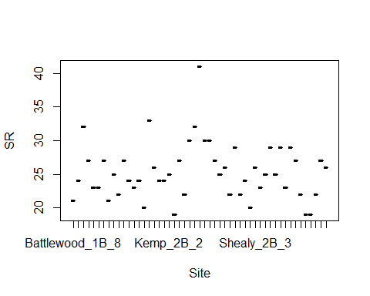

#richness <-read.csv("sr_covs.csv") #SR by sites by point count overall SR #all effort  
#richness$Herbicide <- factor(richness$Herbicide)  
#sapply(richness, mean, na.rm=TRUE)  
#library(psych)  
#sumtable <- describeBy(richness, group=richness$Treatment)  
#sumtable  
#write.table(sumtable, file="C:/Users/woodj/Documents/GRAD SCHOOL - CLEMSON/Project-Specific/R work/USDA-songbirds/USDA-songbirds/SR_summary_by_Treatment.xls",sep="\t")

#begin simple explorations of some exp variables  
plot(richness$SR ~ richness$Age)

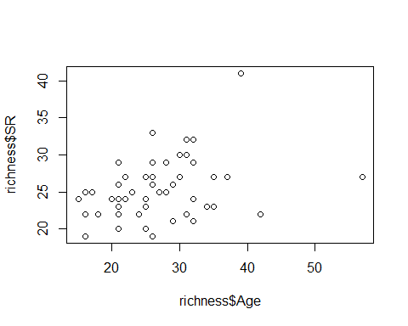

plot(richness$SR ~ richness$Nburns)

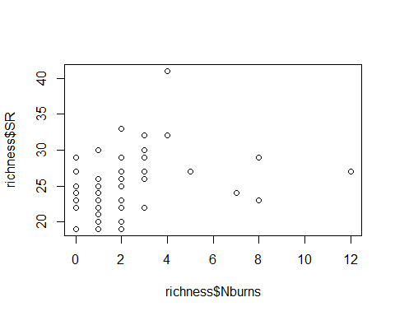

plot(richness$SR ~ richness$BA)

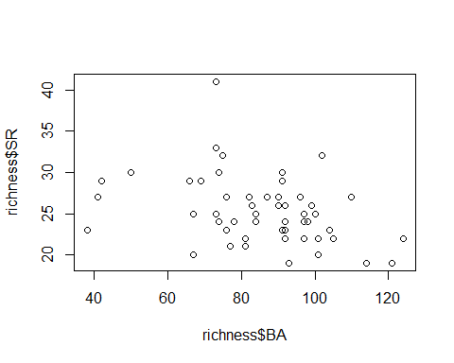

plot(richness$SR ~ richness$Parea)

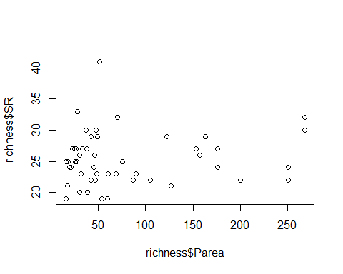

lm(SR ~ Treatment, richness)

##   
## Call:  
## lm(formula = SR ~ Treatment, data = richness)  
##   
## Coefficients:  
## (Intercept) Treatment1B Treatment2B Treatment3B   
## 23.9167 -0.1474 1.0833 4.3690

summary(lm(SR ~ Treatment, richness)) #3B statistically different from others

##   
## Call:  
## lm(formula = SR ~ Treatment, data = richness)  
##   
## Residuals:  
## Min 1Q Median 3Q Max   
## -6.286 -1.958 0.000 1.472 12.714   
##   
## Coefficients:  
## Estimate Std. Error t value Pr(>|t|)   
## (Intercept) 23.9167 1.0932 21.877 < 2e-16 ***  
## Treatment1B -0.1474 1.5161 -0.097 0.92294   
## Treatment2B 1.0833 1.5461 0.701 0.48695   
## Treatment3B 4.3690 1.4898 2.933 0.00518 **   
## ---  
## Signif. codes: 0 '***' 0.001 '**' 0.01 '*' 0.05 '.' 0.1 ' ' 1  
##   
## Residual standard error: 3.787 on 47 degrees of freedom  
## Multiple R-squared: 0.2101, Adjusted R-squared: 0.1596   
## F-statistic: 4.166 on 3 and 47 DF, p-value: 0.01071

plot(SR ~ Treatment, data=richness)

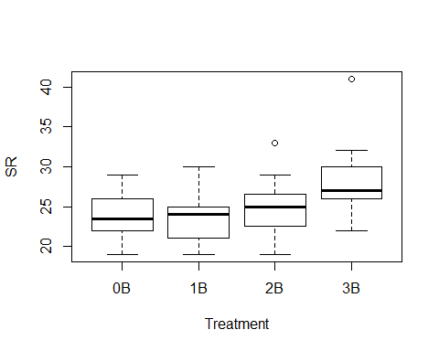

confint(lm(richness$SR~richness$Treatment))

## 2.5 % 97.5 %  
## (Intercept) 21.717346 26.115988  
## richness$Treatment1B -3.197345 2.902474  
## richness$Treatment2B -2.026976 4.193643  
## richness$Treatment3B 1.371878 7.366217

lm(SR ~ Herbicide, richness)

##   
## Call:  
## lm(formula = SR ~ Herbicide, data = richness)  
##   
## Coefficients:  
## (Intercept) Herbicide   
## 25.0952 0.4048

summary(lm(SR ~ Herbicide, richness)) #nothing going on here - no stat sig difference bw 0 or 1

##   
## Call:  
## lm(formula = SR ~ Herbicide, data = richness)  
##   
## Residuals:  
## Min 1Q Median 3Q Max   
## -6.500 -2.798 -0.500 1.702 15.500   
##   
## Coefficients:  
## Estimate Std. Error t value Pr(>|t|)   
## (Intercept) 25.0952 0.9096 27.590 <2e-16 ***  
## Herbicide 0.4048 1.1859 0.341 0.734   
## ---  
## Signif. codes: 0 '***' 0.001 '**' 0.01 '*' 0.05 '.' 0.1 ' ' 1  
##   
## Residual standard error: 4.168 on 49 degrees of freedom  
## Multiple R-squared: 0.002372, Adjusted R-squared: -0.01799   
## F-statistic: 0.1165 on 1 and 49 DF, p-value: 0.7343

plot(SR ~ Herbicide, data=richness)

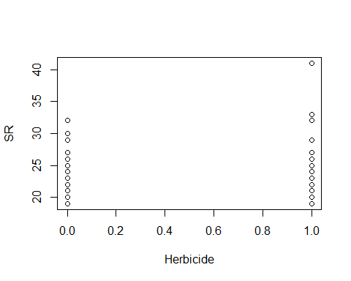

lm(SR ~ Nthins, data=richness)

##   
## Call:  
## lm(formula = SR ~ Nthins, data = richness)  
##   
## Coefficients:  
## (Intercept) Nthins   
## 23.548 1.001

plot(SR ~ Nthins, data=richness)

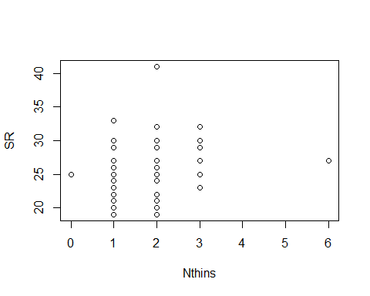

interaction.plot(richness$Treatment, richness$Nburns, richness$SR)

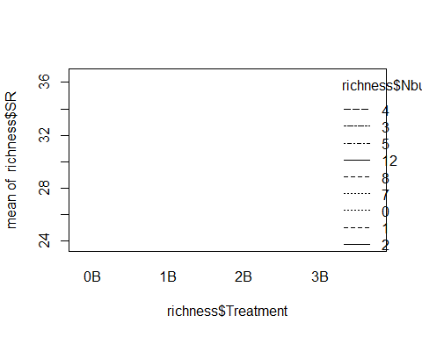

summary(lm(SR ~ Nthins, data=richness))

##   
## Call:  
## lm(formula = SR ~ Nthins, data = richness)  
##   
## Residuals:  
## Min 1Q Median 3Q Max   
## -6.5492 -2.5504 -0.5484 1.4520 15.4508   
##   
## Coefficients:  
## Estimate Std. Error t value Pr(>|t|)   
## (Intercept) 23.5476 1.1820 19.922 <2e-16 ***  
## Nthins 1.0008 0.5811 1.722 0.0913 .   
## ---  
## Signif. codes: 0 '***' 0.001 '**' 0.01 '*' 0.05 '.' 0.1 ' ' 1  
##   
## Residual standard error: 4.052 on 49 degrees of freedom  
## Multiple R-squared: 0.05708, Adjusted R-squared: 0.03783   
## F-statistic: 2.966 on 1 and 49 DF, p-value: 0.09134

plot(SR ~ Nthins, ann=FALSE, data=richness)

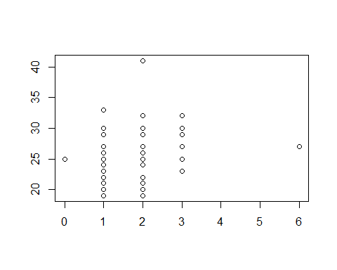

summary(lm(SR ~ Parea, richness)) #so no species-area relationsip?

##   
## Call:  
## lm(formula = SR ~ Parea, data = richness)  
##   
## Residuals:  
## Min 1Q Median 3Q Max   
## -6.2247 -2.7618 -0.0283 1.9814 15.8285   
##   
## Coefficients:  
## Estimate Std. Error t value Pr(>|t|)   
## (Intercept) 24.860424 0.864793 28.747 <2e-16 ***  
## Parea 0.006062 0.008209 0.738 0.464   
## ---  
## Signif. codes: 0 '***' 0.001 '**' 0.01 '*' 0.05 '.' 0.1 ' ' 1  
##   
## Residual standard error: 4.15 on 49 degrees of freedom  
## Multiple R-squared: 0.01101, Adjusted R-squared: -0.009178   
## F-statistic: 0.5453 on 1 and 49 DF, p-value: 0.4638

fit<-lm(SR ~ Treatment + BA + Parea, data=richness)  
summary(fit)

##   
## Call:  
## lm(formula = SR ~ Treatment + BA + Parea, data = richness)  
##   
## Residuals:  
## Min 1Q Median 3Q Max   
## -7.2124 -2.2251 -0.2744 2.0190 12.8754   
##   
## Coefficients:  
## Estimate Std. Error t value Pr(>|t|)   
## (Intercept) 29.010179 3.436070 8.443 7.89e-11 ***  
## Treatment1B -0.659012 1.528123 -0.431 0.6683   
## Treatment2B 0.172570 1.655390 0.104 0.9174   
## Treatment3B 2.957623 1.680215 1.760 0.0852 .   
## BA -0.057715 0.033962 -1.699 0.0961 .   
## Parea 0.007211 0.007739 0.932 0.3565   
## ---  
## Signif. codes: 0 '***' 0.001 '**' 0.01 '*' 0.05 '.' 0.1 ' ' 1  
##   
## Residual standard error: 3.74 on 45 degrees of freedom  
## Multiple R-squared: 0.2625, Adjusted R-squared: 0.1806   
## F-statistic: 3.204 on 5 and 45 DF, p-value: 0.01473

confint(fit, level=0.95)

## 2.5 % 97.5 %  
## (Intercept) 22.089578252 35.9307799  
## Treatment1B -3.736810189 2.4187855  
## Treatment2B -3.161555488 3.5066958  
## Treatment3B -0.426504271 6.3417505  
## BA -0.126117344 0.0106870  
## Parea -0.008377107 0.0227989

anova(fit)

## Analysis of Variance Table  
##   
## Response: SR  
## Df Sum Sq Mean Sq F value Pr(>F)   
## Treatment 3 179.25 59.751 4.2725 0.009749 **  
## BA 1 32.61 32.614 2.3321 0.133732   
## Parea 1 12.14 12.140 0.8681 0.356459   
## Residuals 45 629.33 13.985   
## ---  
## Signif. codes: 0 '***' 0.001 '**' 0.01 '*' 0.05 '.' 0.1 ' ' 1

plot(SR ~ Age, ann=FALSE, type="n", xlim=c(10,60), ylim=c(10,40), data=richness)  
lines(SR~Age,lwd=2, data=richness)

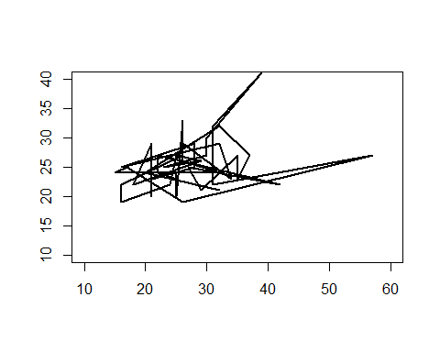

richness <-read.csv("sr_covs.csv")  
levels(richness$Treatment)

## [1] "0B" "1B" "2B" "3B"

quantiles_95<-function(x){  
 r<-quantile(x,probs=c(0.025,0.25,0.5,0.75,0.975))  
 names(r)<-c("ymin","lower","middle","upper","ymax")  
 r  
}  
  
ggplot(data=richness,aes(x=Treatment,y=SR,fill=Treatment))+guides(fill=F)+stat_summary(fun.data=quantiles_95,geom="boxplot")+scale_fill_brewer(type="seq",direction=1,palette="Greens")+labs(x="Burn treatment",y="# of species")+coord_cartesian(ylim=c(19, 33)) +   
 scale_y_continuous(breaks=seq(18, 34, 2))+  
 theme(panel.border = element_blank(),panel.grid.major = element_blank(),panel.grid.minor = element_blank())

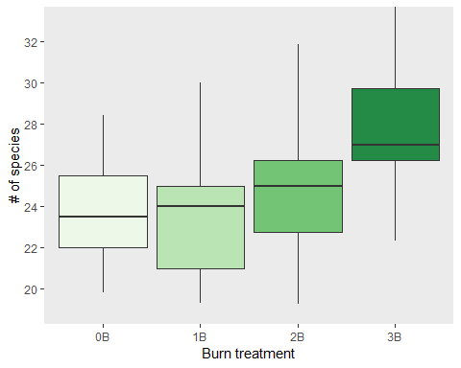

#removed geom_jitter()